SWOT Analysis Worksheet
 | 
aaaa
 | 

SWOT Analysis Questions

 | 
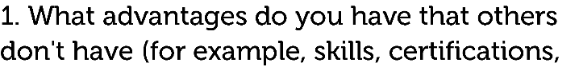  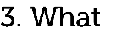     | 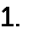      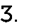    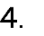      
 | 
  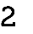  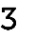    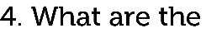 |         

